**PUBLISHED IN DECEMBER 2018**

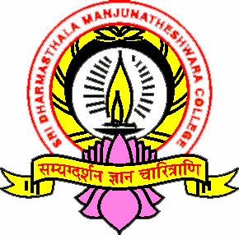

SDM PROFESSIONAL ETHICS

AND

POLICIES

HAND BOOK

IQAC SDMC UJIRE

SRI DHARMASTHALA MANJUNATHESHWARA COLLEGE (AUTONOMOUS), UJIRE-574240

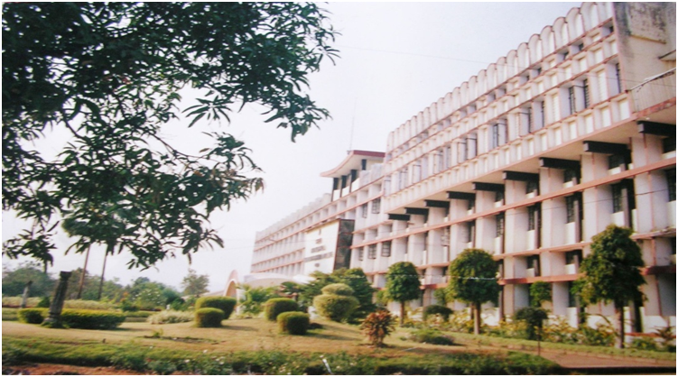

**PUBLISHED IN DECEMBER 2018**